Data Science for Business Project

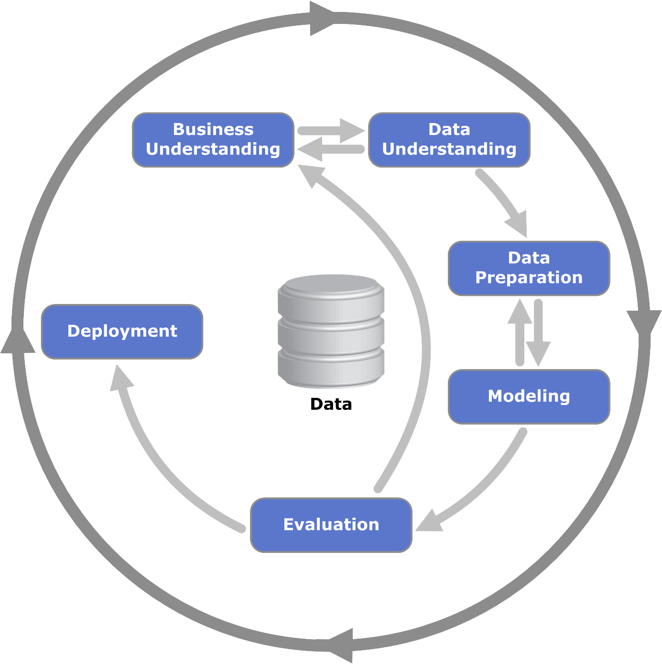

Deliverables:

* Written Report (approx. 2000-3000 words) structured according to the CRISP-DM phases.
* Must include your ra#onale for the choices made, results, interpreta#ons, and recommenda#ons for the business.
* Clear explanaton of your findings and how they impact the business. Jupyter Notebook.
* A video summarises your work and includes clear ra#onale as regards each decision and/choice made. The video is max 7 minutes.
* Clean and well-documented code for data explora#on, prepara#on, modelling, and evalua#on.
* Visualiza#ons and outputs to support your findings.

Table of contents

Business understanding 4

Data understanding 5

# Business understanding

Albert Heijn wants to enhance its advertisements for its customers, it wants to do this by improving customer segmentation, ensuring accurate identification and targeting of customer groups, while avoiding over-segmentation that could reduce marketing effectiveness.

The objective of the analysis is to segment the customers to improve advertising for a better customer experience.

The problem of customer segmentation is important for Albert Heijn because it allows the company to tailor marketing strategies and product offerings to specific customer groups. This leads to more relevant promotions, better customer engagement, increased sales, and improved loyalty.

The potential benefits of customer segmentation for Albert Heijn include more personalized marketing, higher customer engagement, increased sales, improved loyalty, optimized inventory management, and greater operational efficiency.

Success in a project to improve segmentation at Albert Heijn would look like more accurate customer groups, leading to higher engagement with personalized ads, increased sales, improved customer loyalty, and more efficient use of marketing resources. It would also mean better alignment of product offerings with customer preferences and enhanced customer satisfaction, all while maintaining data privacy compliance.

# Data understanding

The data set we are using is a data set from Kaggle which is based on a marketing campaign of what we presume is a supermarket. Based on this information we imagined that this would be a marketing campaign that Albert Heijn did.